DATA-MINING ASSIGNMENT #02

case A:
A Random sample of 80: 20 for Train-Set and Data-Set

01. Decision Tree with Gini index as the impurity measure...

deshan <- read.csv("/home/deshan/Desktop/des.csv")

attributes(deshan)

install.packages(“rpart”)

install.packages(“rpart.plot”)

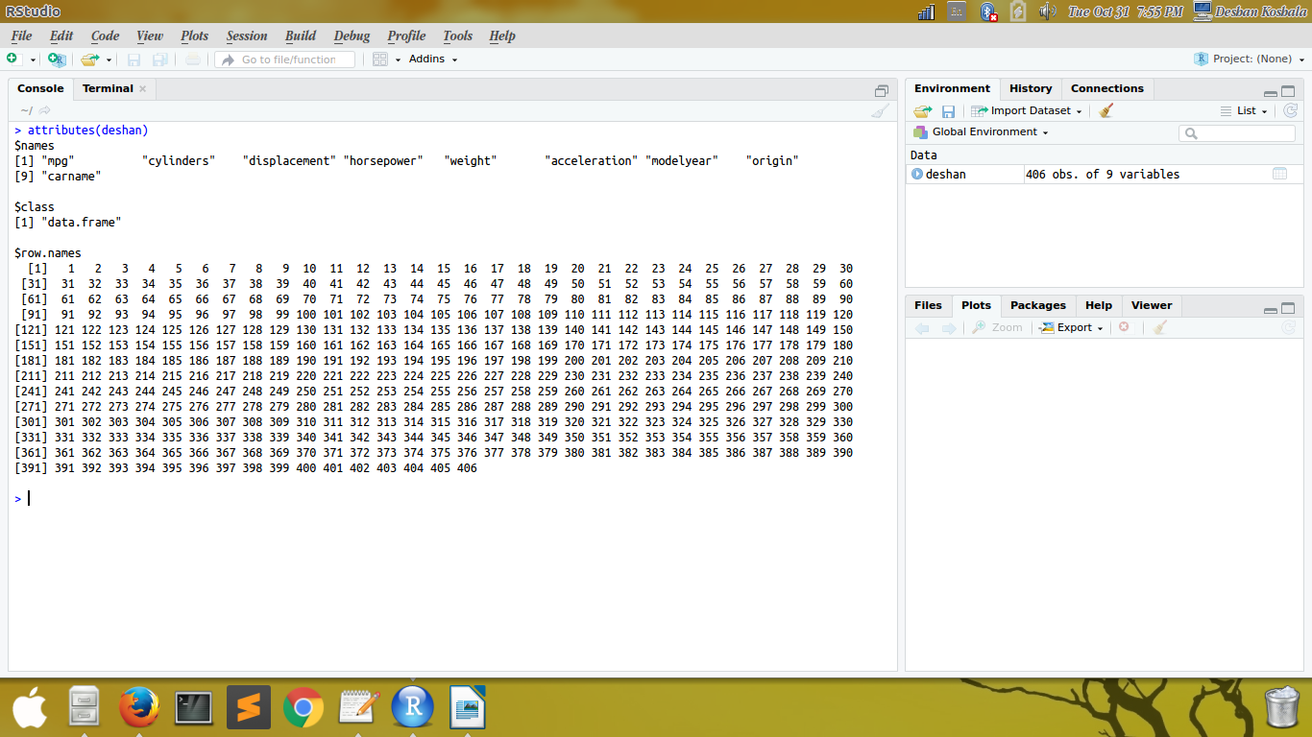

library(rpart)

library(rpart.plot)

set.seed(1234)

ind<-sample(2,nrow(deshan),replace = TRUE,prob = c(0.7,0.3))

deshantrain<-deshan[ind==1,]

deshantest<-deshan[ind==2,]

myformula <- mpg ~cylinders+displacement+horsepower+weight+acceleration+modelyear+origin

deshan_rpart<- rpart(myformula,data =deshantrain,parms = list(split = "gini"),
control=rpart.control(minsplit = 10))

plot(deshan_rpart)

rpart.plot(deshan_rpart)

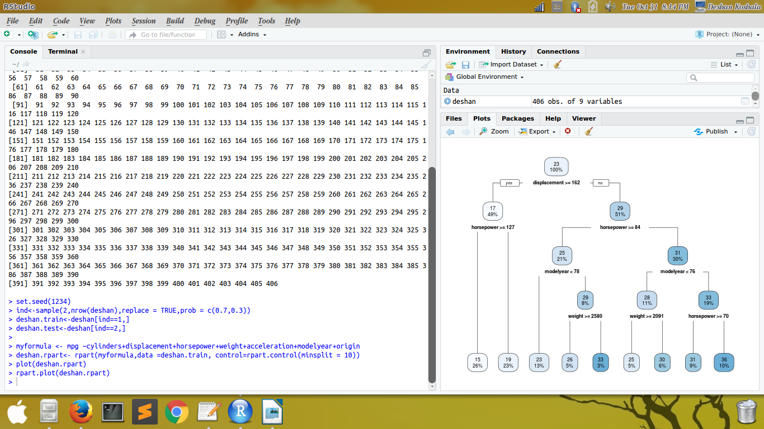

02. Decision Tree with Entropy as the impurity measure...

deshan <- read.csv("/home/deshan/Desktop/des.csv")

set.seed(1234)

ind<-sample(2,nrow(deshan),replace = TRUE,prob = c(0.7,0.3))

trainData<-deshan[ind==1,]

testData<-deshan[ind==2,]

myformula <- mpg ~cylinders+displacement+horsepower+weight+acceleration+modelyear+origin

deshan_ctree <- ctree(myformula, data=trainData)

plot(deshan_ctree)

plot (deshan_ctree, type="simple")

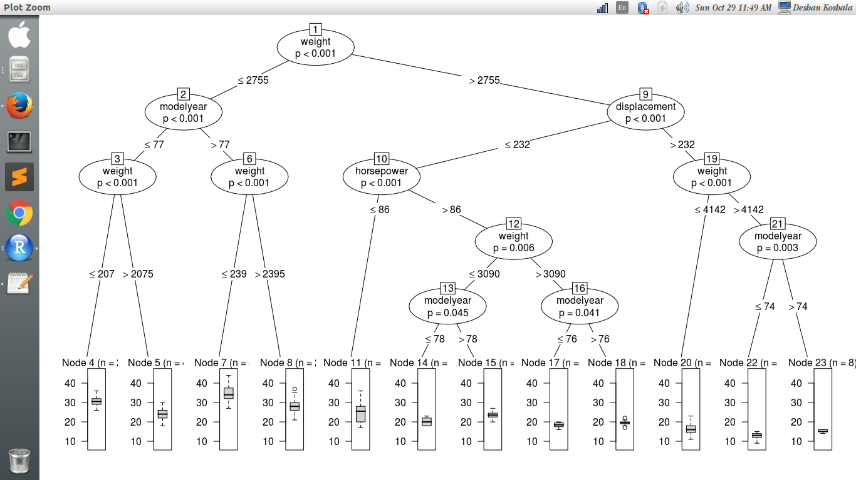

library(e1071)

ind <- sample(2, nrow(deshan), replace=TRUE, prob=c(0.8, 0.2))

train <- deshan[ind==1,]

test <- deshan[ind==2,]

e1071model <-naiveBayes(mpg ~., data = train)

e1071modelprediction <- predict(e1071model,test)

e1071model

